1. Configure VPC peering in cross regions.

Step 1: Create a VPC Peering Connection (Requester Account)  
1. Go to the VPC console in the requester account.  
2. Click on "Peering Connections" and then "Create peering connection".  
3. Select "Another AWS account".  
4. Enter the AWS account ID and VPC ID of the accepter account.  
5. Choose the VPC in the requester account.  
6. Click "Create peering connection".  
Step 2: Accept the VPC Peering Connection (Accepter Account)

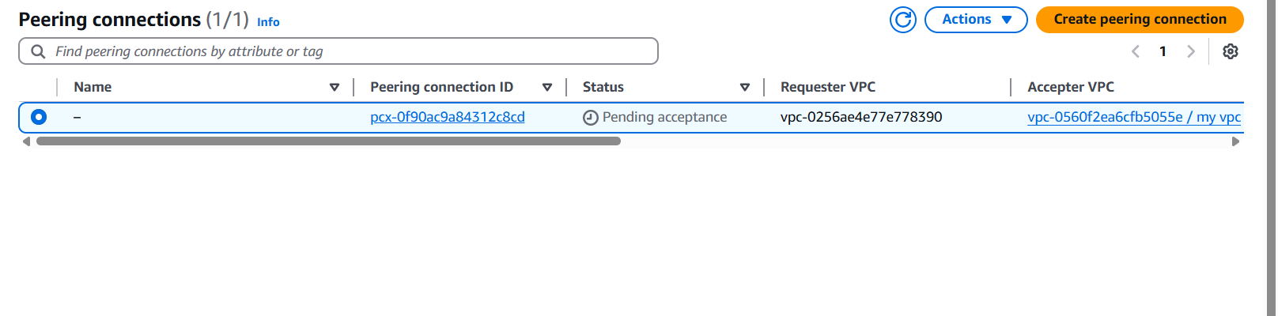

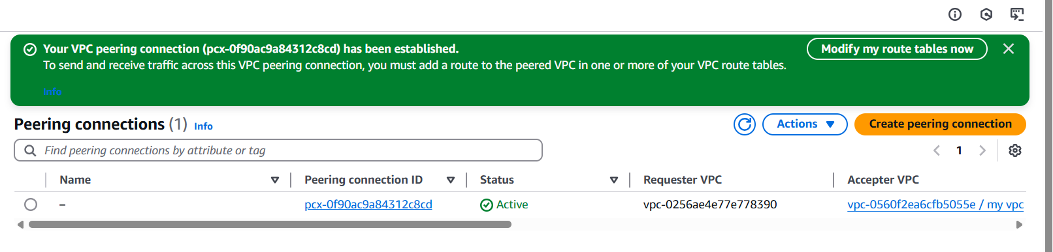

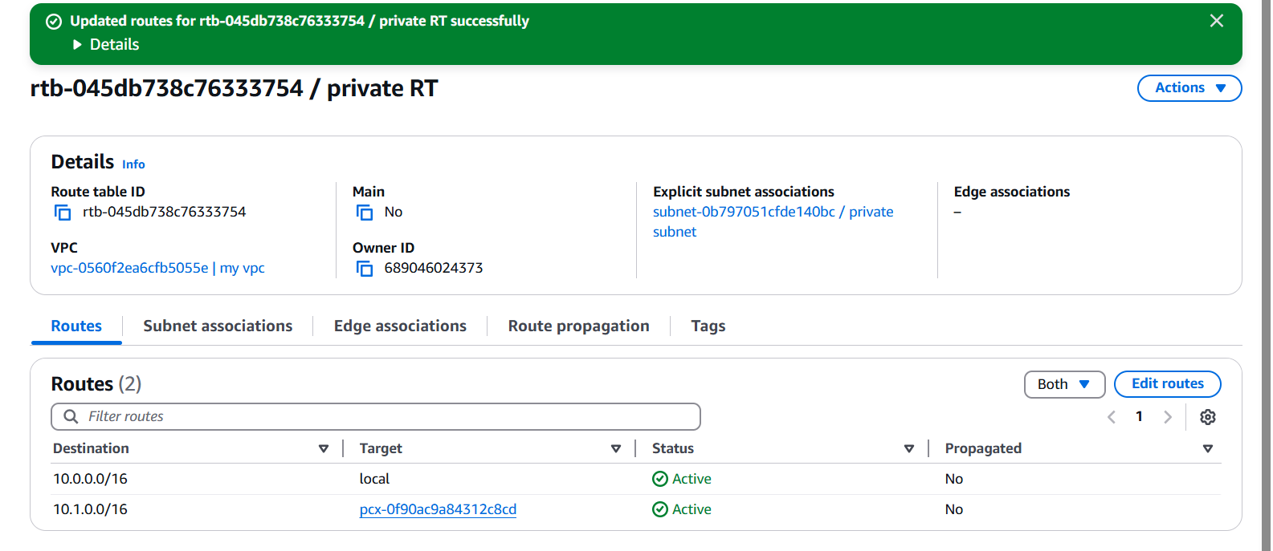

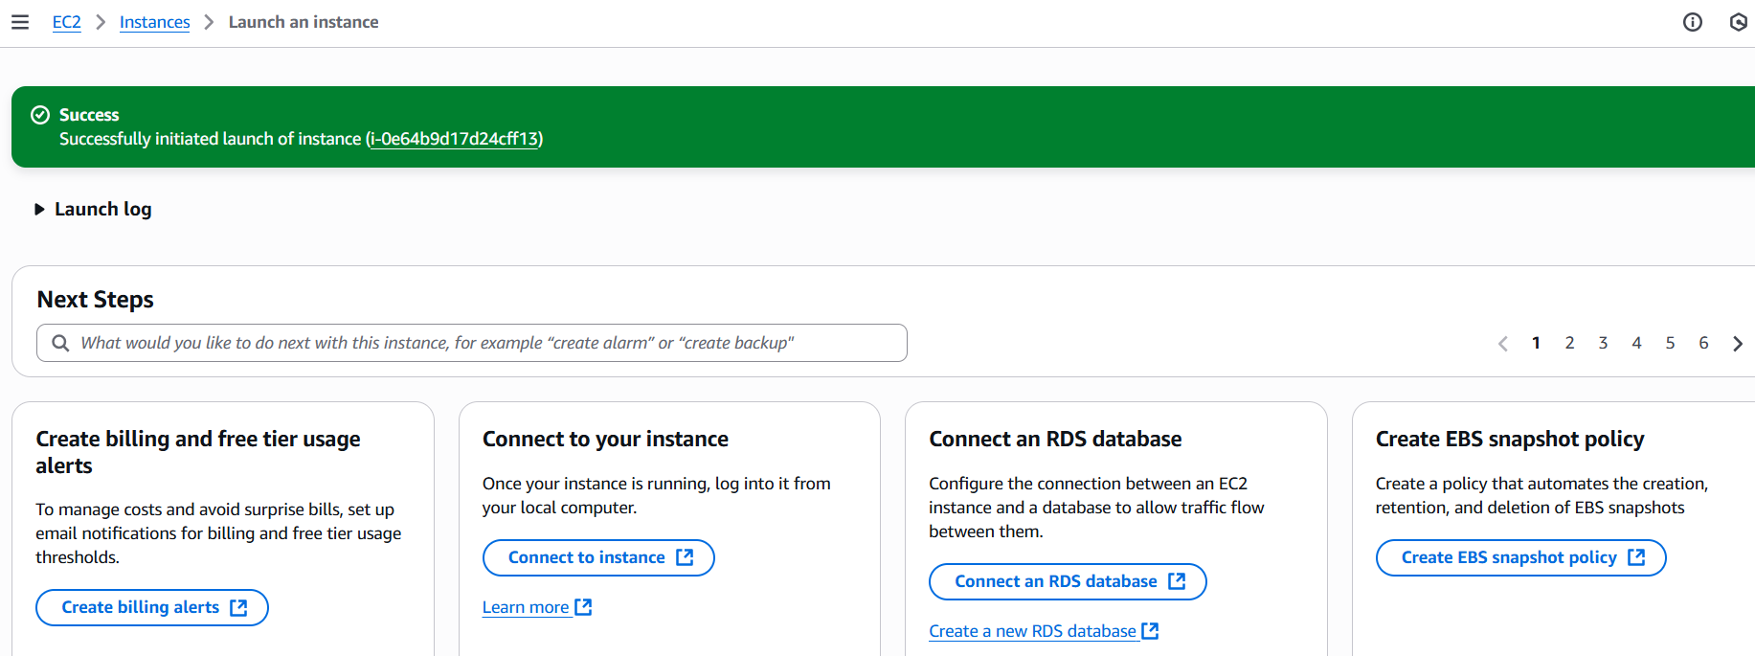

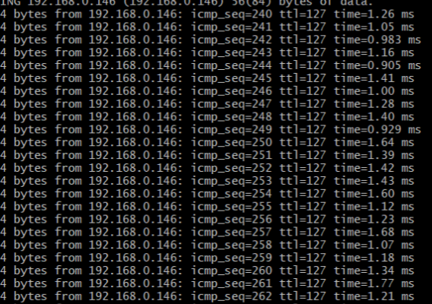

1. Purchase one domain from godaddy.

Open a browser Go to godaddy website  
Click on sign in /sign up  
Search for domain(select domain for testing purpose)  
Continue and make it yours  
Remove full domain protection  
Disable create a free website  
Remove professional emails  
Continue and then pay  
After purchasing Go to account --->In products ---->We  
can find our domain

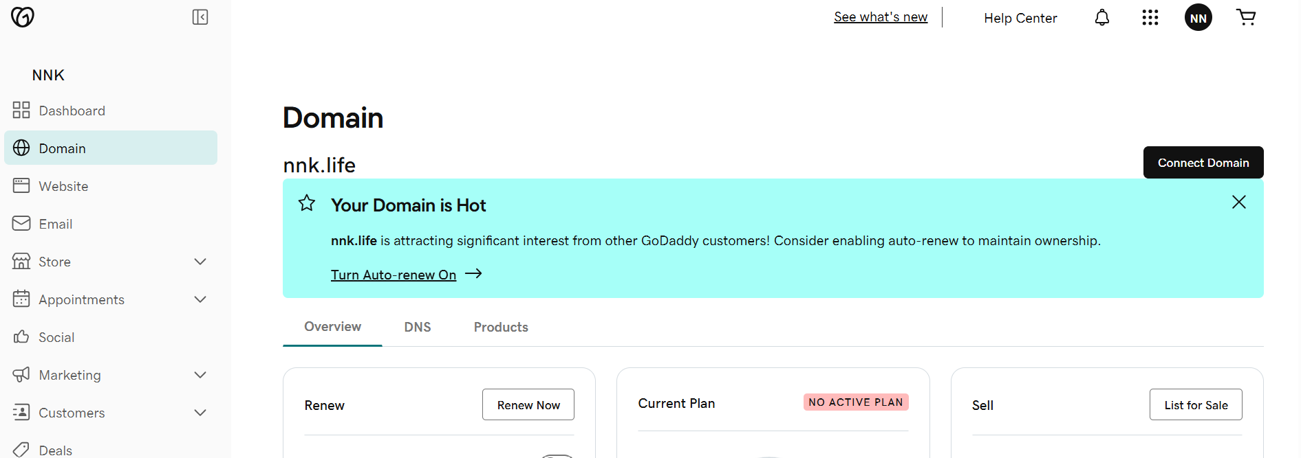

1. Deploy static website in s3.

Go to s3 bucket  
In properties scroll down we can find Static website   
hosting  
Click on and Enable and upload index and error   
document  
And also upload these document from local to S3 bucket   
and make it public

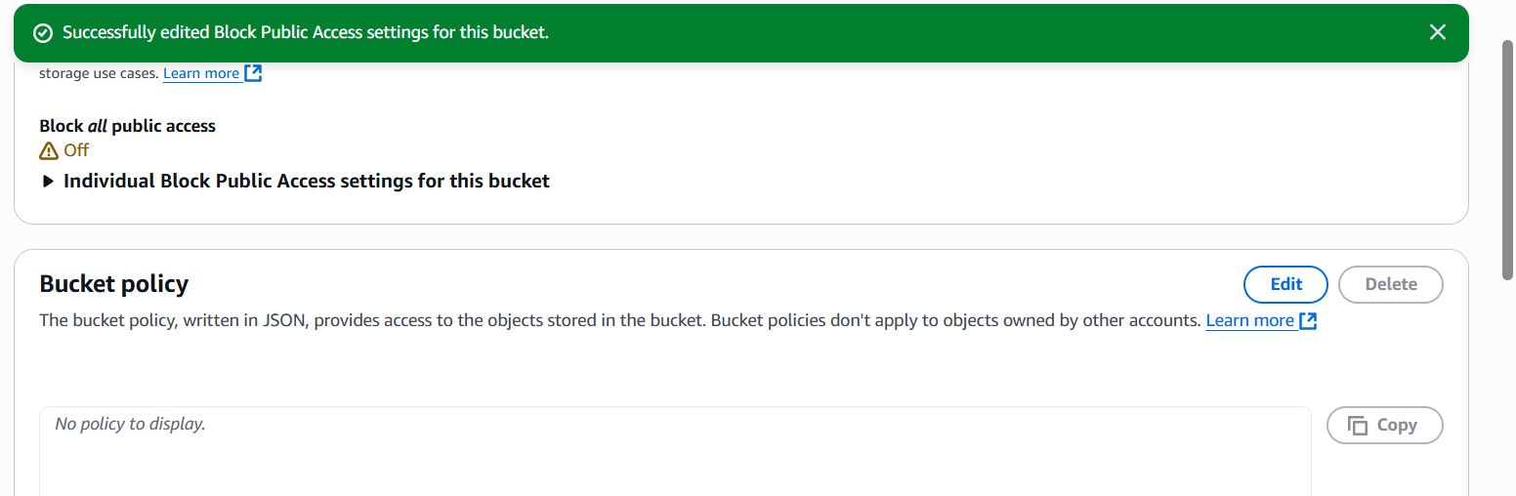

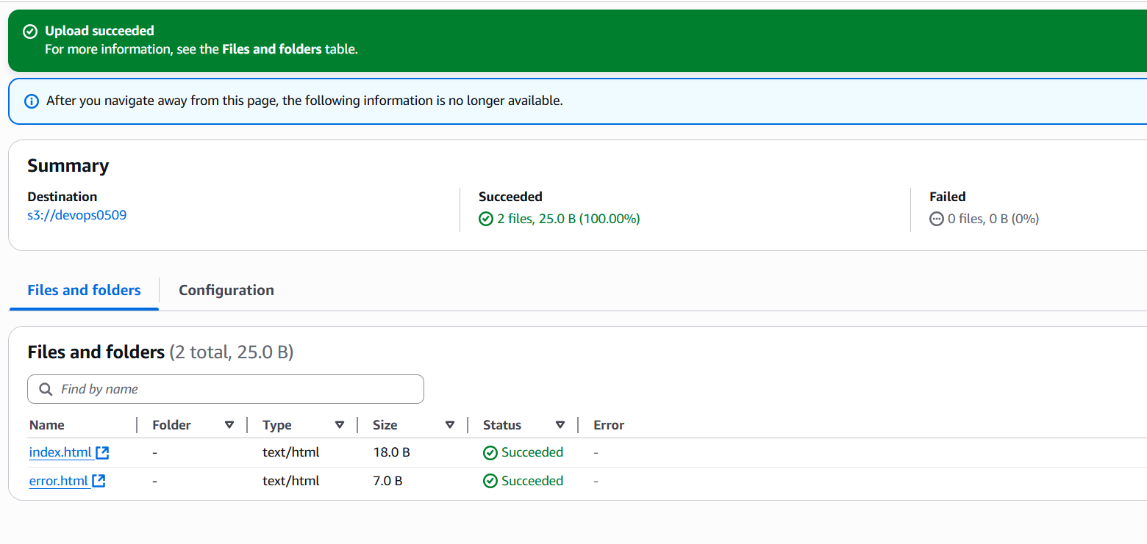

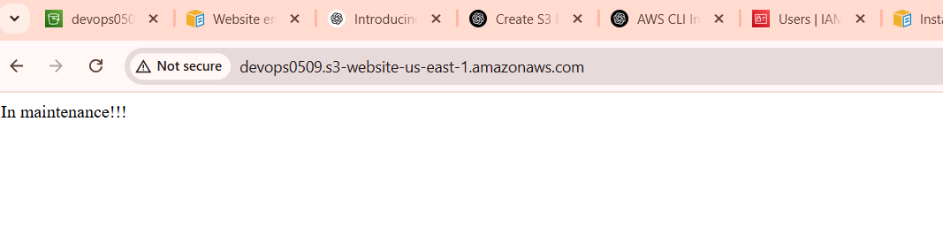

1. Create CDN and attach one SSL certificate.

🡺Go to Cloud front and create Distribution

🡺Choose original domain name

🡺Now we need to create ACM to Cloud front

🡺Searching ACM in aws console or got distribution and in

settings click on edit

🡺In edit request certificate

🡺And create on ACM certificate

🡺Now Go to Route53 ---->Go to hosted zones--->Records

Create record

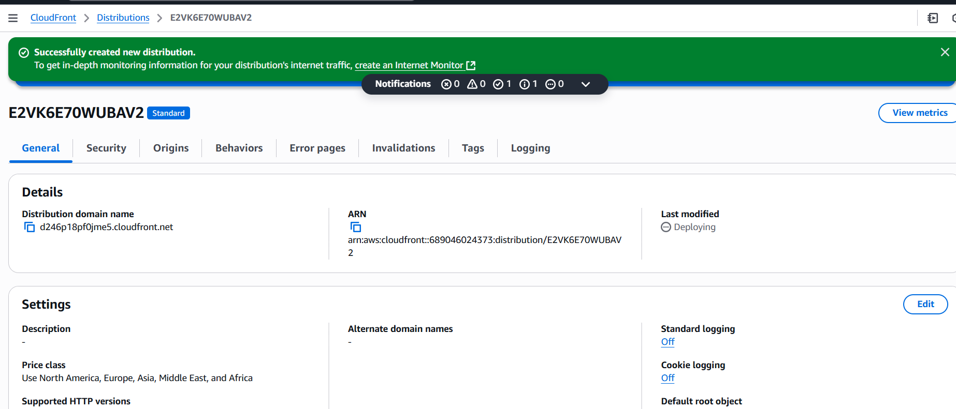

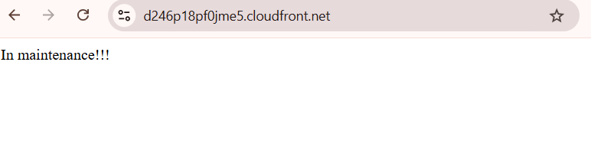

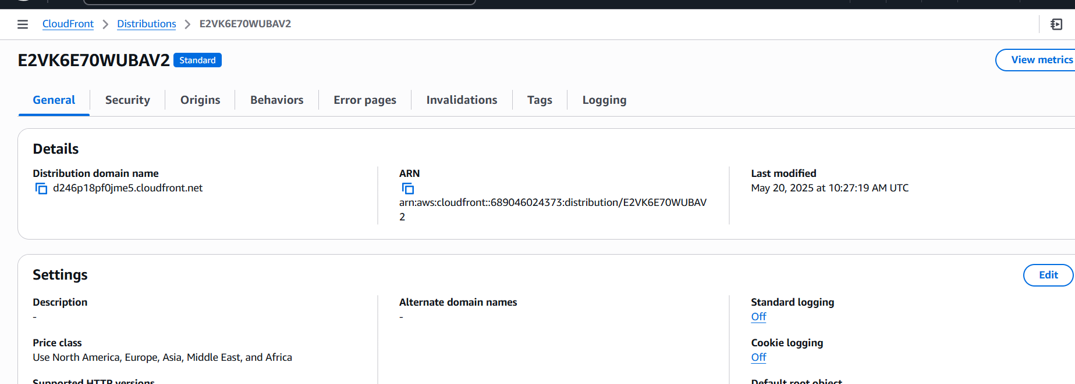

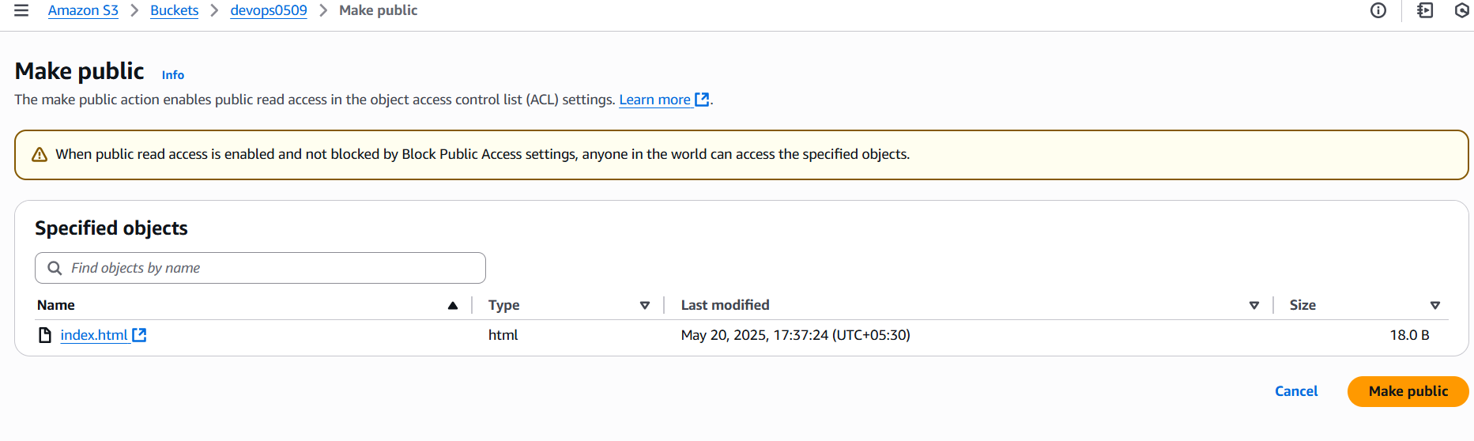

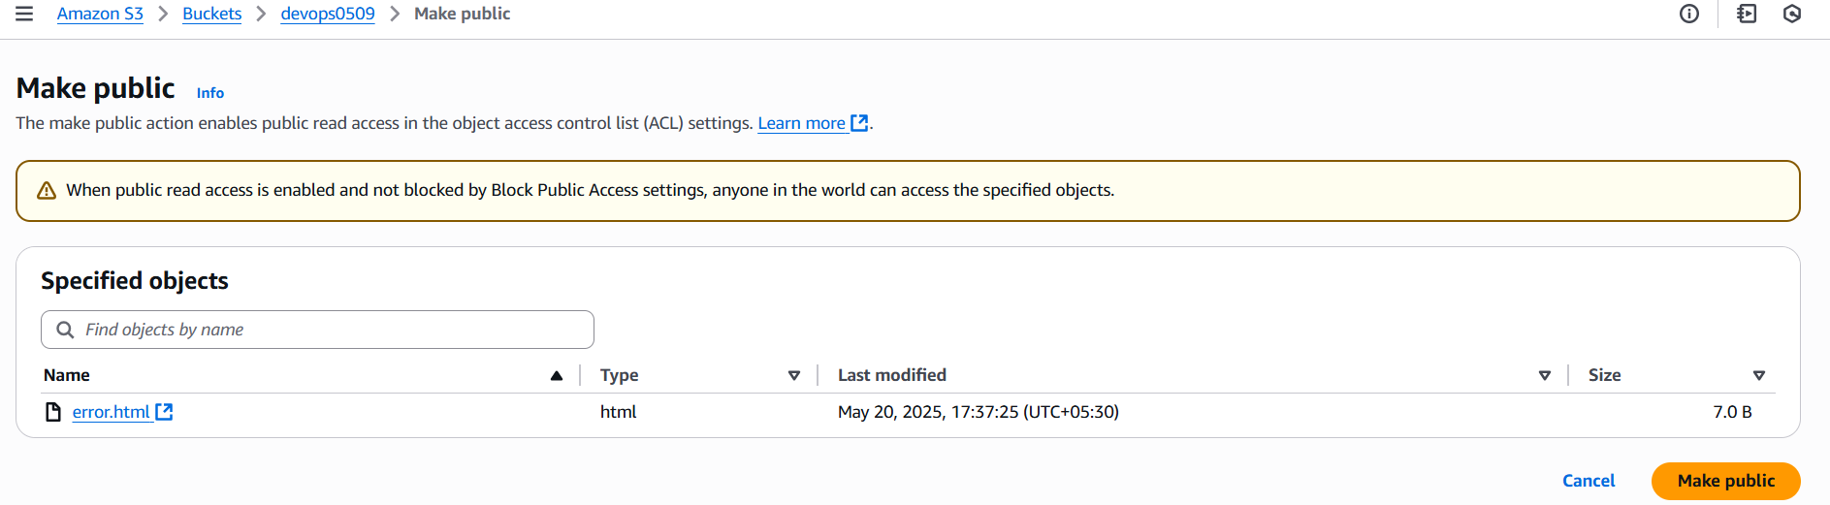

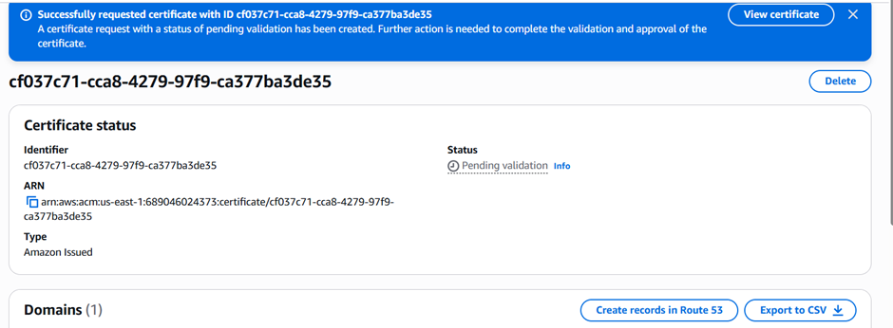

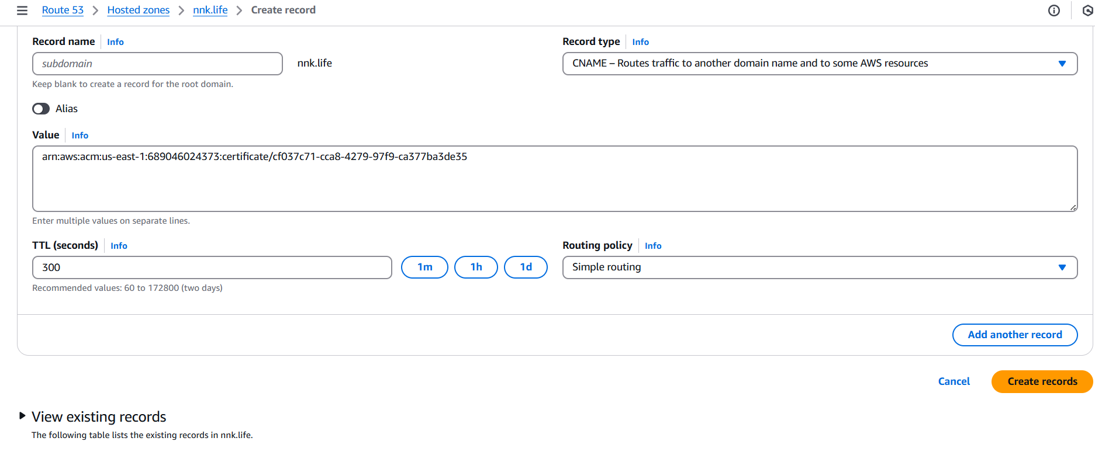

1. Create Route53 hosted zone and MAP the domain with CDN.

1.Log in to AWS Management Console.  
2. Navigate to Route 53 dashboard.  
3. Click "Create a hosted zone".  
4. Enter your domain name.  
5. Click "Create hosted zone".

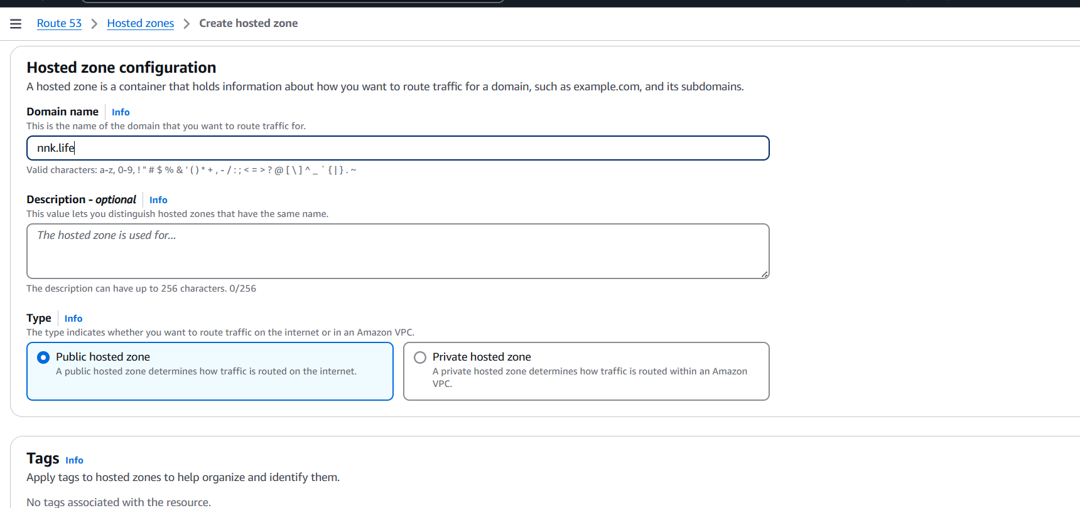

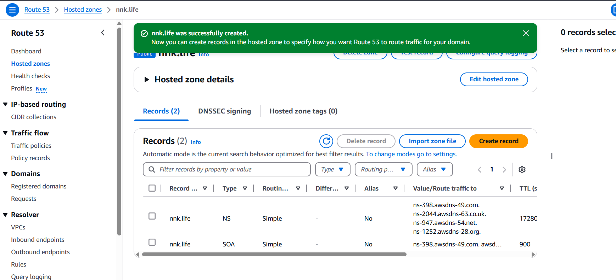● Once the hosted zone is created, Route 53 will create 4 NS   
(Name Server) and SOA records for your domain. Note   
down the four Name Server (NS) values provided.  
● Now we have to update Name servers at GoDaddy. This is   
the crucial step that tells the internet to look at Route 53 for  
your domain's DNS information.  
● Go to your GoDaddy account dashboard:  
○ Find your purchased domain name and go to its DNS   
management settings

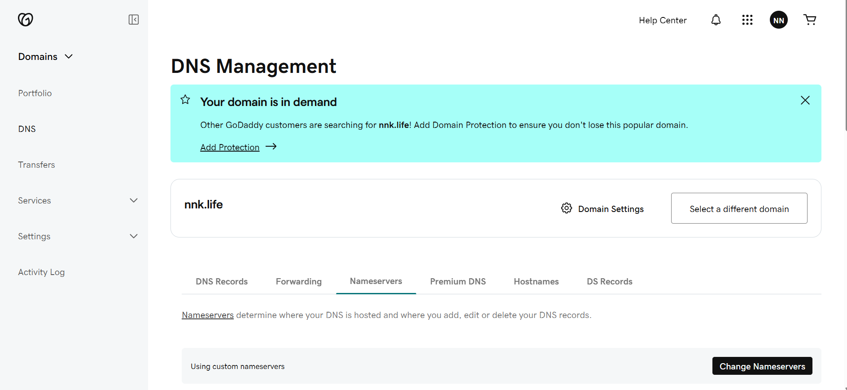

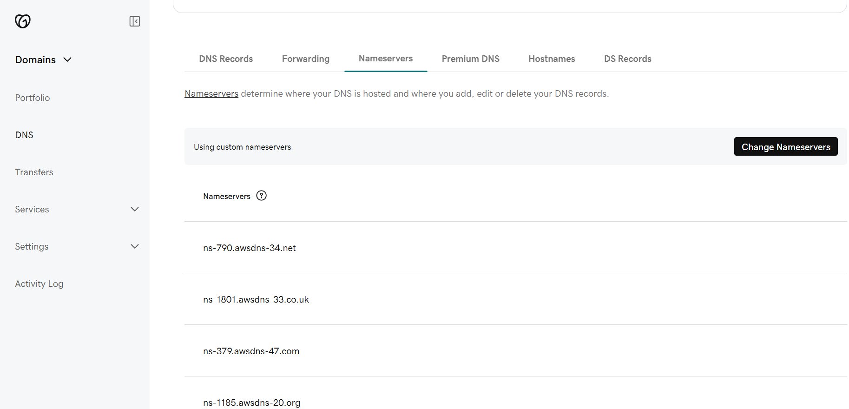

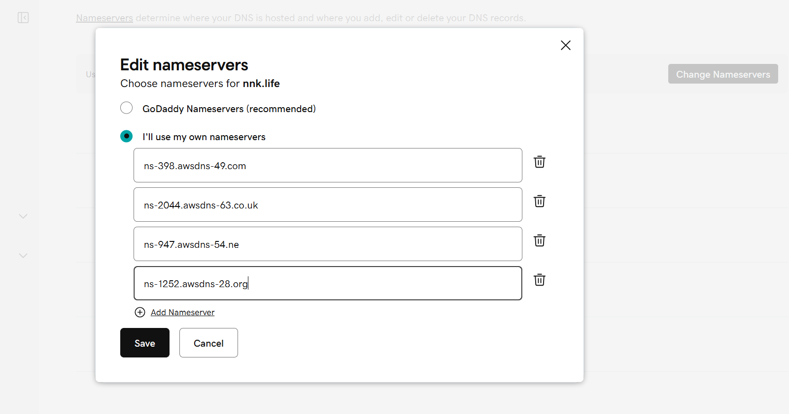

1. Update the index.html in s3 bucket and the updated file should be accessible by using domain name.

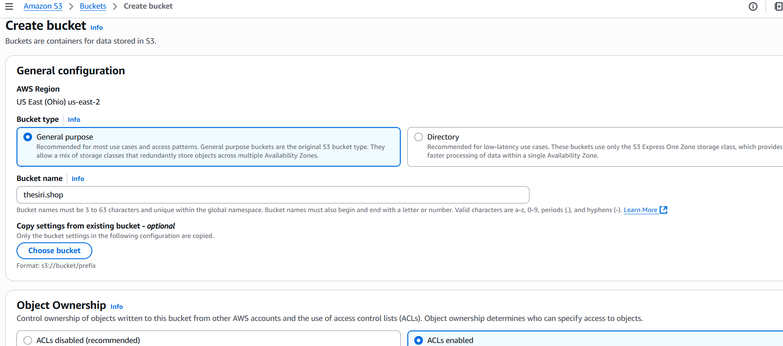

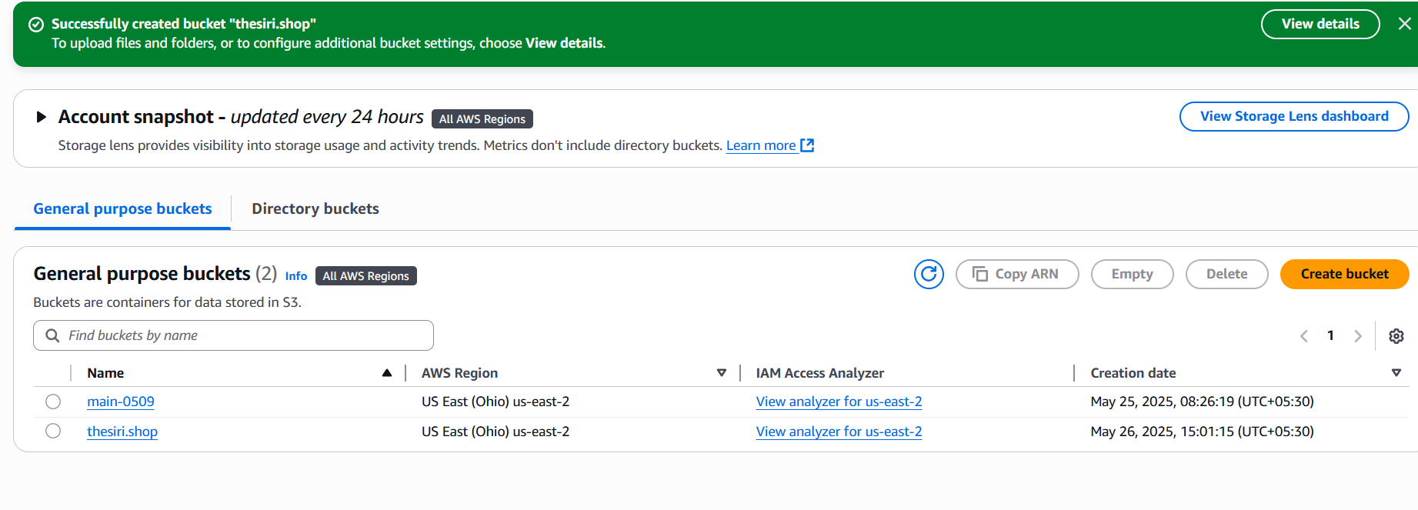

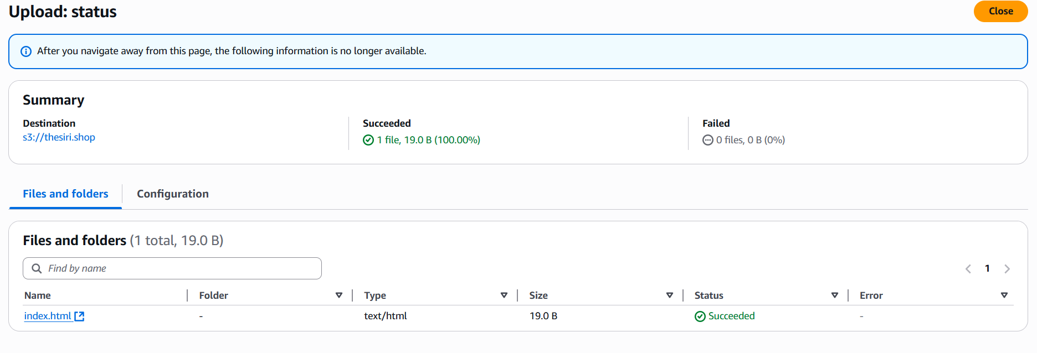

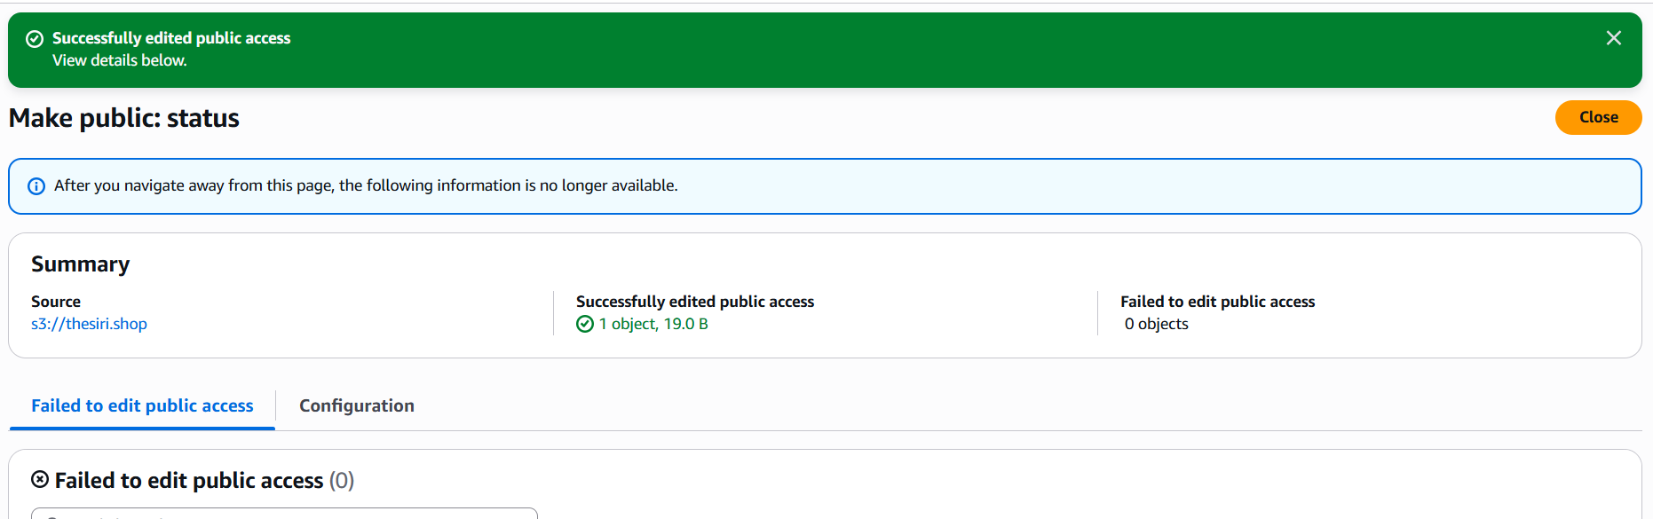

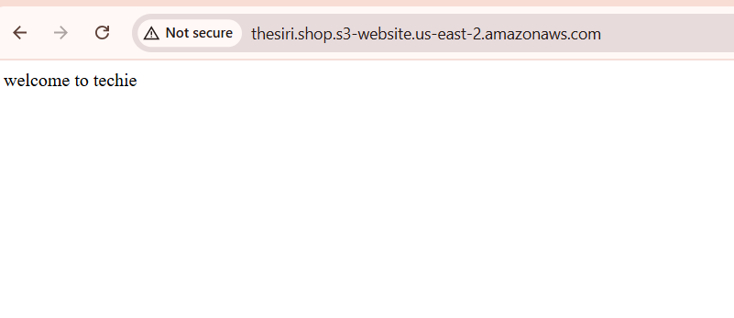

1. Share the Domain name in slack to test the connetivity.

